

**THE UNIVERSITY OF BRITISH COLUMBIA OKANAGAN CAMPUS**

**FACULTY OF APPLIED SCIENCE, SCHOOL OF ENGINEERING**

ENGR 499 Capstone Final Design Report: Open Source Recumbent E-Trike

**Faculty Advisor and Client:**

Dr. Ian Foulds

**Group 2 Team Members:**

Agam Aneja (65683799)

Ahmed Abdo (85193456)

Anirudh Devarakonda (53472585)

Isaac Joseph (90324872)

Vrushank Kekre (32252991)

**Executive Summary**

By creating, producing, and electrifying an open-source Python recumbent tricycle, our initiative seeks to solve the shortage of accessible, inexpensive, and environmentally friendly transportation choices for the people of Kelowna. The main objective of the project is to develop a design and manufacturing method that is simple to replicate for a safe and effective tricycle that anybody can construct. Design, Manufacturing, Electrification, and Software Integration are the four main divisions of the project.

The electric recumbent trike must meet certain requirements in order to be compliant with BC government rules for motor-assisted vehicles. The trike's electric motor should not be more powerful than 500 W, and its top speed shouldn't be more than 32 km/h. To ensure rider safety and control of the vehicle, the design must have elements that stop the motor from turning on when the user releases the accelerator, stops pedaling, or applies the brake.

The adoption and marketing of the Python recumbent trike within the community can be facilitated by working with these organizations. The School of Engineering and Dr. Ian Foulds, our faculty adviser who is also the client for whom we are developing the tricycle, are the major stakeholders in the project.

The project's success depends on conforming to criteria and restrictions, such as financial restraints, local laws, and the availability of materials and resources. In order to build and construct a bike that satisfies the demands of Kelowna's people while maintaining within the law, it is important to take these rules and limitations into account. This will eventually help the initiative succeed and encourage the community to choose more sustainable, reachable, and inexpensive transportation options.

**Table of contents:**

**List of Figures: 5**

**List of Tables: 5**

**I. Introduction 6**

1. Background and Need Statement 6

**II. Problem Specification 7**

1. Overview and Specifics of the Problem 7

2. Requirements and Constraints 7

3. Project Partner and Stakeholders 9

4. Health and Safety Risks 9

Design Phase: 10

Ergonomics and Stability: 10

Visibility: 10

Manufacturing Phase: 10

Material Quality and Assembly: 10

Safe Manufacturing Practices: 10

Electrical Phase: 11

Battery Safety: 11

Electrical System Design: 11

Operational Health and Safety Risks: 11

Rider Skill and Experience: 11

Traffic Conditions: 12

Maintenance and Inspection: 12

Weather Conditions: 12

5. Applicable Standards 12

6. Economic, Environmental, and Societal Considerations. 14

Table 1: Economic, Environmental, and Societal Considerations. 14

**III. Design Process 15**

Design Phase: 15

Concept Generation: 15

Design Testing: 17

Manufacturing Phase: 18

Testing and Evaluation: 18

Design Refinement: 19

Prototype Development: 20

Electrification Phase: 22

System Selection: 22

Circuit Development: 23

Testing and Evaluation: 24

Design Refinement: 25

Software Integration Phase: 25

Requirements Gathering: 25

App Development: 26

Testing and Evaluation: 27

Design Refinement: 28

Electrical and software integration: 28

**IV. Solution Generation and Selection 29**

Frame and Mechanical Solution: 29

Brief Review and Description of Previous Solution 31

**V. Final Design Details 34**

Engineering Judgment and Methods 36

Engineering Tools 38

Manufacturing tools: 38

**VI. Final Design Evaluation 39**

1. Assessment of Final Design 39

2. Success or Failure 39

3. Recommendations for Further Work 40

**VI. Conclusion 41**

**References: 41**

**APPENDIX A: Motor Wattage and Operation Cost 43**

**APPENDIX B: Stress Testing Report Using SolidWorks 44**

**APPENDIX C: Final Trike Images 45**

# 

# 

# List of Figures:

1. Final Frame Design Deformation Test at 209 Deformation Scale 17
2. Right Kingpin Image 21
3. Left Kingpin Image 21
4. Top view of the frame with the front wheel
5. Modular Electrification System 22
6. System wiring diagram including Arduino circuit 23
7. Arduino circuit configuration 24
8. SKID App user interface examples 26
9. Final CAD of Trike Frame 35

# List of Tables:

1. Economic, Environmental, and Societal Considerations. 15
2. Material List for the manufacturing division 20
3. Pros and cons of Delta vs Tadpole design 29

# 

# 

# 

# I. Introduction

## Background and Need Statement

Kelowna has experienced rapid growth in all sectors in recent years, with its population expanding significantly, leading to inadequate transportation infrastructure and options for residents (Western Investor Staff, Castanet, 2022; Seymour, 2021). The people of Kelowna have discovered that the city's present public transportation system is insufficient for meeting their needs because of challenges including unequal distribution of transit lines, safety concerns, and punctuality problems (Barnes, 2022). This has a disproportionately negative impact on students and locals in areas like Quail Ridge who depend heavily on public transit to move about the city. As Kelowna grows, innovative and sustainable transportation solutions are becoming more and more important.

To address the pressing need for affordable, accessible, and sustainable transportation in Kelowna, particularly for the growing student population, we have developed an open-source, electric recumbent trike. This cutting-edge method of transportation provides a useful and sustainable substitute for conventional modes of transportation like cars and buses. Our distinctive design and production method seeks to make it simple for anyone to construct and modify their own trikes, hence promoting wide adoption. With our two-step procedure, anyone may construct a regular recumbent trike or electrify it for more convenience, based on their requirements and preferences. This adaptable system meets the population's various demands while encouraging eco-friendly lifestyles and lowering the city's carbon impact. By offering an easily replicable design for a safe, efficient, and user-friendly trike, we aim to provide a sustainable and effective alternative to Kelowna's current transportation challenges.

# II. Problem Specification

## Overview and Specifics of the Problem

This project calls for the design, development, and implementation of an open-source, easily replicable recumbent trike solution with modular electrification components. This solution must offer the inhabitants of Kelowna a cheap, accessible, and sustainable form of transportation that can be created at home or in a shop without the need for heavy machinery. By offering a useful and effective substitute for conventional transportation choices, this project seeks to alleviate the mobility issues faced by the city's most vulnerable groups, including mid-to-low-income citizens, seniors, and people with disabilities. The recumbent trike must be built with features that support user safety and vehicle control in addition to conforming to local laws and safety requirements. The project calls for a thorough investigation of the specifications and restrictions involved in creating the recumbent trike, including financial constraints, regional laws, and the accessibility of materials and resources. The criteria and limits must be taken into consideration when evaluating how well it addresses the open-ended, complicated challenge of sustainable transportation. The project's success will ultimately depend on the team’s capacity to design and build a functional recumbent trike and open-sourced build guide, along with the ability to add modular electrification and execute the finished product effectively.

## Requirements and Constraints

The success of the electric recumbent trike project hinges on meeting specific requirements and constraints. Our primary requirements are to design an affordable, easy-to-build, and safe electric recumbent trike. Constraints include budget limitations, local regulations, and the availability of materials and resources.

To comply with the BC government's regulations for motor-assisted vehicles, our electric recumbent trike must meet certain criteria:

* Be equipped with an electric motor not exceeding 500 W output power.
* Have fully operable pedals to ensure user control and safety.
* Limit the maximum speed to 32 km/h (19.9 mph) to comply with regulations and reduce the risk of accidents. (ICBC, n.d. )

The electric trike design must also feature a mechanism to prevent the motor from engaging when the user stops pedaling, releases the accelerator, or applies the brake, ensuring rider safety and control.

In terms of legal requirements, electric recumbent trike users in BC are not required to possess a driver's license, vehicle registration, or insurance. However, riders must be at least 16 years old and wear a bike helmet while operating the trike. Our project will adhere to the Motor Assisted Cycle Regulation, BC Reg 151/2002, ensuring that the electric recumbent trike complies with all necessary standards (Theelectricbike, 2022).

By considering these regulations and constraints, we can create a safe, affordable, and accessible electric recumbent trike that meets the needs of Kelowna's residents while remaining within legal boundaries. Our project's success will promote the adoption of sustainable, affordable, and accessible transportation alternatives in the community.

## Project Partner and Stakeholders

The recumbent trike's implementation and marketing throughout the community depends on potential project partners and stakeholders. We can establish a network of assistance and cooperation that enables the initiative to succeed by involving neighborhood companies, educational institutions, government organizations, and members of the community.

Dr. Ian Foulds, our faculty advisor, serves as the client for whom we are creating this trike. The participation of Dr. Foulds ensures that we will have access to insightful guidance and direction as the project develops, increasing our chances of success. Dr. Foulds was also able to provide us with some salvaged parts from a previous bike project to help lower our materials costs and can leverage his position as a UBC Engineering professor to publish our findings and open-source build guide for future projects to use.

The project's success is also valuable to the School of Engineering since it demonstrates the department's dedication to innovation, sustainability, and community involvement. Given the school’s involvement as our sponsor, we are offered vital connections and resources that can advance the initiative. The project's success also stands to enhance the school's standing as a pioneer in engineering and environmentally friendly practices.

## Health and Safety Risks

The development and usage of the recumbent trike present various safety risks during the design, manufacturing, electrical, and operational phases. Addressing these risks is crucial to ensure the safety and well-being of those involved in the project and the end-users of the trike.

### **Design Phase:**

#### *Ergonomics and Stability*:

The design of the recumbent trike must prioritize rider comfort, support, and stability. An inadequate or poorly designed seating position may result in discomfort, muscle strain, or increased risk of accidents due to instability. Proper ergonomics and a low center of gravity will enhance rider safety and comfort. Our steering system and control alignment must also adhere to a strict level of accuracy to ensure the safety of the rider and the integrity of the structures.

#### *Visibility*:

The lower profile of a recumbent trike compared to traditional bicycles may affect its visibility on the road, potentially increasing the risk of accidents with other vehicles. The design should incorporate features such as reflective materials, or lighting systems to increase visibility and minimize the risk of collisions.

### **Manufacturing Phase:**

#### *Material Quality and Assembly*:

The selection of materials and components used in the trike's construction must adhere to high-quality standards to ensure durability and reliability. Materials must be selected such that they are high stress resistant while also maintaining a low overall weight to keep our design as lightweight as possible. Metals used in the frame must be suitable for welding, as well as safe to work with at home. Additionally, proper assembly and quality control processes must be implemented to detect and resolve any manufacturing defects that could compromise the trike's structural integrity.

#### *Safe Manufacturing Practices*:

The manufacturing process must follow established safety guidelines to protect the workers involved in the trike's assembly. This includes using appropriate personal protective equipment (PPE), maintaining a clean and organized workspace, and adhering to safety protocols when handling tools and equipment.

### **Electrical Phase:**

### *Battery Safety*:

The trike's electrical system must comply with safety standards for battery usage, storage, and disposal. Incorrect handling or storage of batteries could result in overheating, short circuits, or fire hazards. Ensuring proper battery management is vital, and the selection of a rated electrical system designed for weather-resistant use will be crucial. Additionally, our design must ensure battery safety for users by keeping the battery and its wires out of the users' way and appropriately resistant to weather conditions/malfunctions.

### *Electrical System Design*:

The electrical wiring and components must be designed and installed in a way that minimizes the risk of electrical faults, short circuits, or other hazards. Additionally, our bike must implement fail-safe measures in the event of a dead or malfunctioning battery.

### **Operational Health and Safety Risks:**

### *Rider Skill and Experience*:

The unique design and riding position of the recumbent trike may require a learning curve for new riders. Providing a comprehensive guide on riding the trike can help riders familiarize themselves with the trike and minimize the risk of accidents due to inexperience. Additionally, this guide will include safety regulations for riders to adhere to, such as the proper use of a helmet and other protective wear.

### *Traffic Conditions*:

Riders must be aware of local traffic laws and conditions while using the trike. Navigating congested or high-speed traffic areas can pose increased risks for recumbent trike riders. Encouraging the use of designated bike lanes, and bike-friendly routes, and promoting defensive riding strategies will help reduce the likelihood of accidents.

### *Maintenance and Inspection*:

Regular maintenance and inspection of the trike are essential to ensure its continued safe operation. Worn or damaged components can compromise the trike's performance and safety. Providing guidelines for routine maintenance and inspections will help users identify and address potential issues before they become serious hazards.

### *Weather Conditions:*

Adverse weather conditions, such as rain, snow, or ice, can significantly affect the trike's traction and handling. Riders should exercise caution when operating the trike in poor weather conditions, and the design should incorporate features that enhance stability and control in various weather scenarios.

By addressing these safety risks during the design, manufacturing, electrical, and operational phases of the recumbent trike, we can create a safe and reliable transportation solution that promotes sustainable and accessible mobility for the residents of Kelowna.

## Applicable Standards

Standards play a vital role in ensuring the safety, reliability, and performance of the recumbent trike. Adhering to these standards during the design, manufacturing, and operational phases of the project will help ensure compliance with regulations and best practices, ultimately resulting in a safer and more effective product. Some of the applicable standards for this project include:

Motor Assisted Cycle Regulation, BC Reg 151/2002: This regulation governs the requirements for motor-assisted cycles in British Columbia. It sets out specific standards for electric motor power, speed limitations, and functional pedals, among other requirements. Ensuring that the electric recumbent trike complies with these regulations is crucial for its legal operation in BC.

Local Traffic and Road Safety Regulations: Ensuring that the electric recumbent trike complies with local traffic laws and road safety regulations is essential for its safe and legal operation. This may involve adhering to requirements for lighting systems, reflectors, and other visibility-enhancing features, as well as following guidelines for safe cycling practices.

By following these applicable standards and regulations, the electric recumbent trike project can ensure the development of a safe, reliable, and compliant transportation solution. Adhering to these standards will help promote the trike's adoption within the community while ensuring that it meets the needs of Kelowna's residents in a responsible and effective manner.

## Economic, Environmental, and Societal Considerations.

| **Type** | **Consideration** |
| --- | --- |
| Economic | - Total cost less than $1500 |
|  | - Price of the battery and electrical system should be equal to or under $500 |
|  | - Price of the Frame and mechanical components should be equal to or under $1000 |
| Environmental | - Electrical components should be compatible with standard public chargers |
|  | - Safe disposal of scrap materials and electrical components must be outlined |
|  | - Sustainable design and method must minimize environmental impact of building process |
| Social | - Trike (including the frame and electric components) should weigh less than 70 pounds |
|  | - The trike must minimize social disturbance by adhering to road standards |
|  | - The app should be built on both Android and iOS Platforms |
| Manufacturing | - Minimize waste resources via salvaging and repurposing materials |
|  | - Ease of assembly and avoiding overcomplexity |
|  | - Quality Control |
|  | - Manufacturing Safety |

### Table 1: Economic, Environmental, and Societal Considerations.

Economic considerations include keeping the project cost-effective and promoting its financial benefits for users. Environmental considerations involve minimizing the trike's ecological footprint and promoting eco-friendly lifestyles. Societal considerations include addressing the diverse needs of Kelowna's population, enhancing the quality of life, and fostering a sense of community through shared sustainable transportation goals.

# III. Design Process

Our approach to this project follows four logical phases: The design phase, the Manufacturing phase, the Electrification phase, and the Software Integration phase. The design process for the recumbent trike involves adopting an iterative approach to effectively address the complexities of the project. This method allows for continuous improvement and refinement throughout the design, manufacturing, electrical, and software development stages. By designing the bike so that the foundations of every following phase are laid down during the previous phase, setbacks due to errors in secondary stages have minimal impact on their primary phases. This approach also ensures that we maintain the modular design objective of our project. As each phase only serves to build upon and improve on its predecessor, this minimizes the risk of unintentionally implementing a primary phase in a way that would make it reliant on its secondary phases. For example, having the pedaling system of the base bike is non-functional without the electrical components.

## Design Phase:

### Concept Generation:

The initial concept generation is one of the most critical steps in our project. It serves as the foundation for all tasks in this project as well as the timeline of the project. Any lackluster or subpar decisions made in this stage would result in increased errors, wasted resources, and timeline disturbances down the line.

The first step in the process of generating the concept is to identify our objectives and their priorities, constraints, limitations, resource management, and manufacturing processes. Our objectives for the design were to create a cheap, safe, ergonomic, replicable, and easily manufactured recumbent bike design with minimal skills.

The first major decision in this phase was which frame design to follow. There are two main frame designs to choose from, a delta design, and a tadpole design. The difference between these two designs is the location of the two wheels relative to the body. Delta trikes have two wheels in the back and one in the front, while tadpole bikes have two wheels in the front and one wheel in the back. To make this decision a pros and cons list for both designs were generated using our most important factors.

Once an initial design was constructed, the next step was to decide on assembly and manufacturing methods. Taking into account the fact that we will be making the recumbent bike out of metal, three joinery methods were discussed, brazing, threaded fasteners, and welding. To make this decision we took into account the integrity of the joints, complexity required, equipment availability, ease of use, and finally skill requirements.

Lastly, the material selection was made during this phase as well. To choose our material we took into consideration weight, availability, and cost. Our choice of material would heavily impact the design of the frame as well, as different materials provide us with different tensile and sheer strengths allowing for changes to all the geometrical shapes of our components for the frame.

### Design Testing:

After a frame design was decided on, a CAD model of the frame was made to test out the effects of different material choices on the frame’s ability to withstand the forces, as well as the overall weight of the bike.

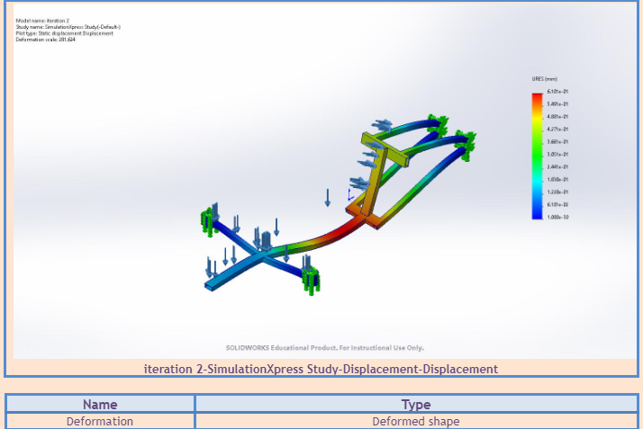

*Figure 1 - Final Frame Design Deformation Test at 209 Deformation Scale*

We were able to accurately test the design’s structural integrity by varying our material choices and the entire geometry of the frame with zero additional cost or prototype manufacturing. Due to the cost and availability constraints, our material choices were restrained to carbon-steel alloys and aluminum alloys. During this process, we designed our frame and stress-tested it. We then provided our results to our Faculty Advisor, Dr. Ian Foulds, to verify our design's viability and provide us with helpful feedback. A full testing report is attached in *Appendix B.*

## Manufacturing Phase:

### Testing and Evaluation:

To ensure the prototype is functional, reliable, and safe for use, many different methods of testing were used during the construction of the prototype. Joints being one of the most structurally integral components of the trike, they were designated the highest testing priority.

We applied three main methods for structural testing, impact testing, continuous load application, and visual inspection. Every component was tested when manufactured, as well as after joining. When applying impact tests we used forces larger than our expected values by an approximate factor of five. This test was applied multiple times on the same areas in rapid succession. This test was mainly utilized to ensure the safety of the prototype in the case of crashes, or rough terrain. The continuous load tests were done using loads larger than our expected values by a factor of three. This test was used to ensure the reliability and functionality of the prototype after prolonged use under intended conditions, and its integrity in the case of unintended loads. Finally, visual inspection was one of our most utilized methods. This method was heavily used in the testing of our welds for joints. Ensuring the welds were done properly was done by checking for inconsistent weld beads, porosity, insufficient penetration, and melt thru.

All of these testing methods were very vital in the manufacturing process, as the early discovery of errors, and points of weaknesses allowed us to address them as efficiently as possible.

### Design Refinement:

In addition to the lack of manufacturing experience on the team, the nature of our project forced us to utilize many different resources and make adjustments due to the availability of materials and equipment. As a result of this, during prototype development, many different design changes were made to both the frame and our methods of choice. This is not to say once a change was made it was final, as we ran into more problems and discovered new issues that needed to be addressed, even more changes were made to not only the initial design but to every updated version of our design.

### Prototype Development:

For the prototype creation, we used mainly steel alloys due to their higher manufacturability, and high strengths allowing for a more compact design, and low cost. This was utilized in combination with Gas Metal Arc Welding(GMAW) to create the main components of our frame.

During this process, the stock materials were acquired in bulk and used to custom manufacture all the frames of our prototype.

| Two 16 gauge 1x1x25 Hollow square steel tubes | Two 16 gauge 1x1x23 Hollow square steel tubes | Two 16 gauge 1x5 Hollow steel rods | Two 16 gauge  1x1x13 Hollow square steel tubes |
| --- | --- | --- | --- |
| Two 16 gauge 2.5x2.5 Hollow steel rods | Two 16 gauge 2x1x60 Hollow square steel tubes | One 16 gauge 1x30 Hollow steel rods |  |

Table 2 Material list

All of these materials were then cut, ground and welded to fit our needs. During the frame-building phase many materials were lost due to errors, we managed to salvage what we could from these materials and repurpose them for smaller uses on the frame, such as refortification of joints.

Many components of the prototype had to be custom-made as well. Although we scavenged as many possible parts as we can from run-down bikes and trikes alike, some components had to be made to fit the specific design of our trike. For example one of the components that you can not buy or find on other bikes are the kingpins.

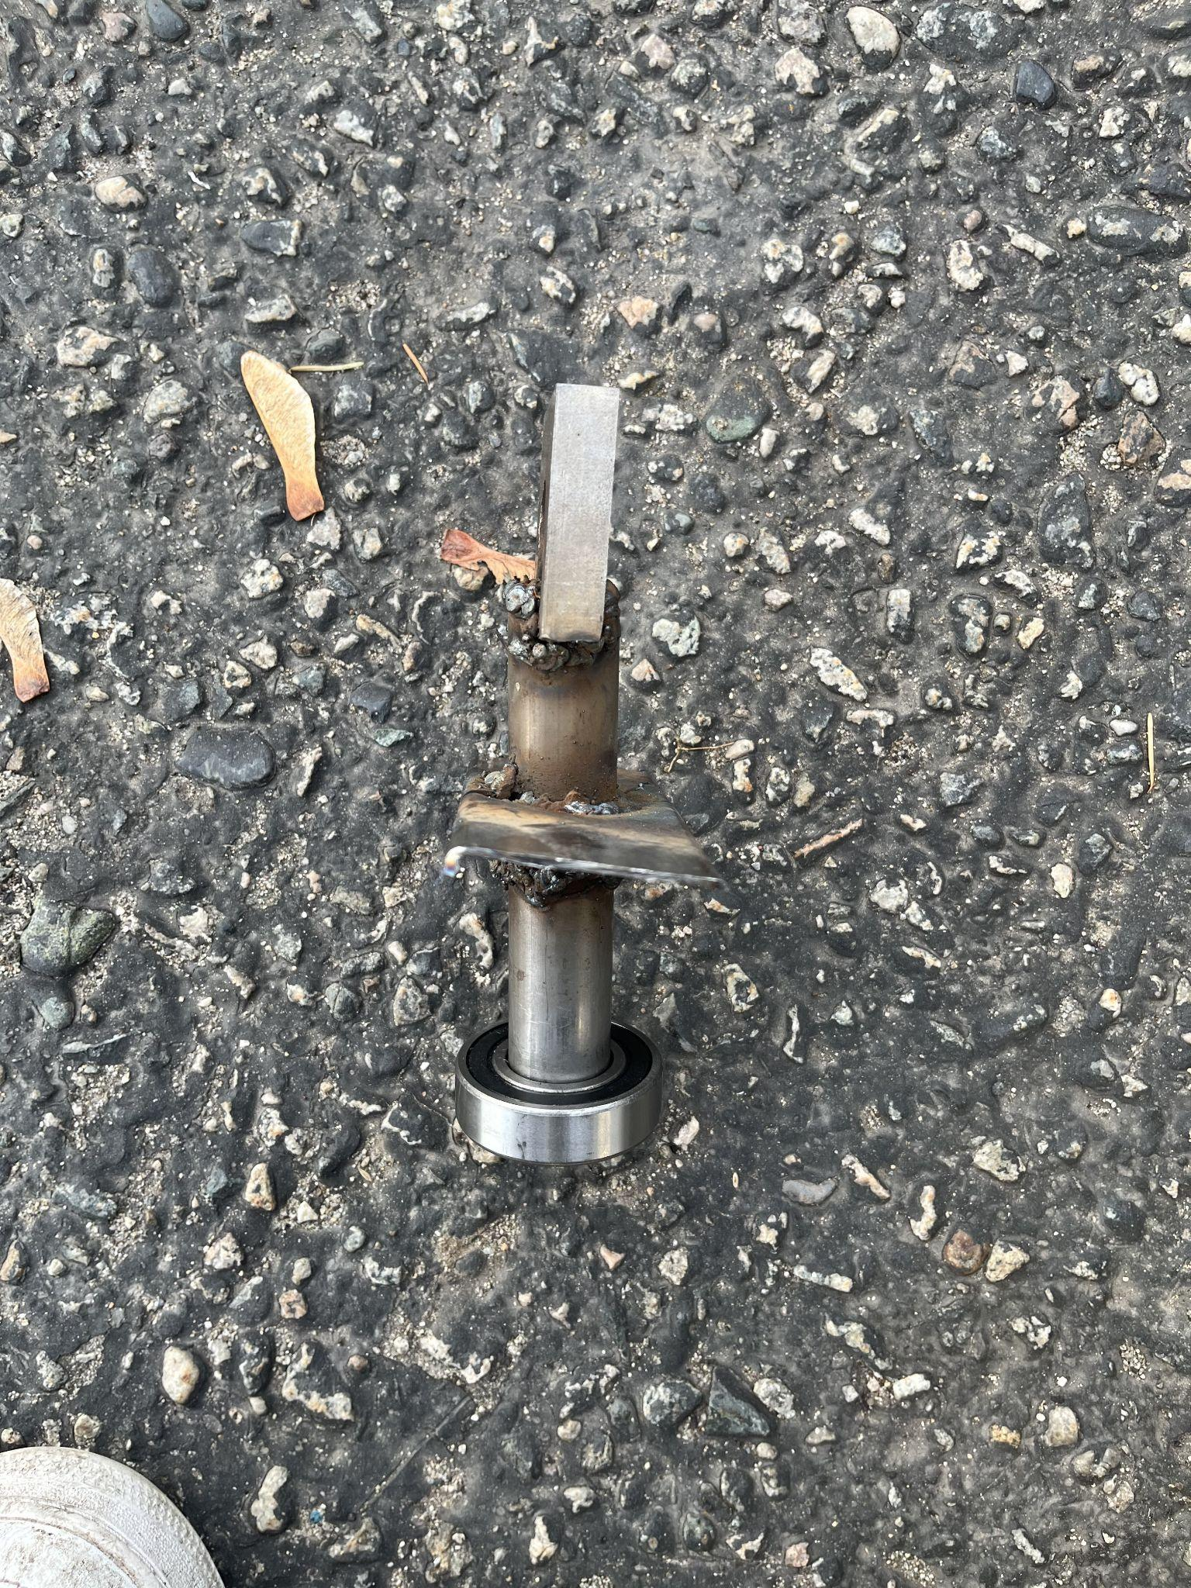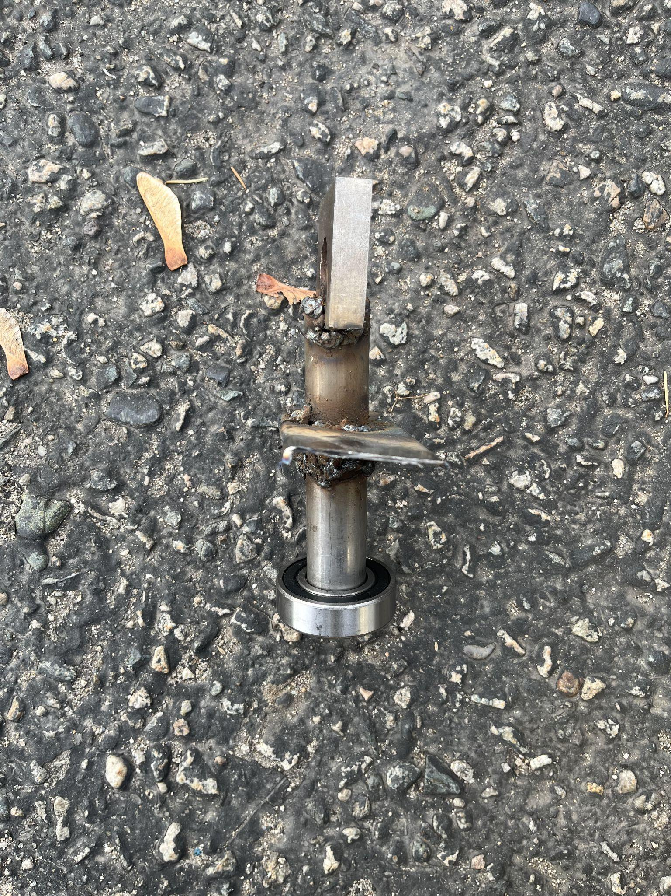

*Figure 2: Right Kingpin Figure 3: left Kingpin*

As can be observed from the figures above, these components require to be at very specific angles. These angles are what dictate and control the camper of our wheels, which heavily affects the steering capabilities of the bike.

The prototype itself underwent many changes during this phase. As what was possible to be done was becoming more apparent, we had to adopt a trial-and-error model of assembly to attain the best results we can with the available resources.

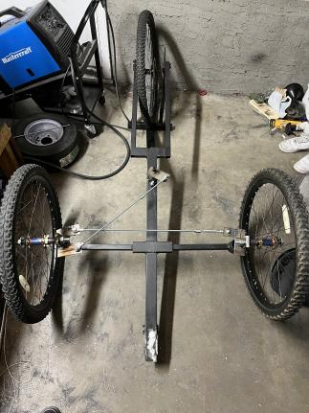

*Figure 4: Top view of the front wheels, with steering mechanism along with the kingpin/bearing attachment- Prototype of Steering Design.*

The final prototype we built succeeded in meeting the objectives we set out. Trial runs showed it functions very efficiently as a transportation method in a very reliable manner.

## **Electrification Phase:**

### System Selection:

Develop an electrical system for the recumbent trike, considering factors such as battery type, motor selection, and power management. For this project many electrical systems and components were considered based on their overall costs, feasibility and performance. A hub motor wheel was chosen for its efficiency and ease of integration with the trike's design. The motor is connected to an ESC (Electronic Speed Controller) which manages the motor's speed and power consumption using a 48V battery source. The electrical system we chose for this project included a comprehensive kit consisting of a throttle and double hall pedal assist sensor (PAS) to control motor output, an LCD screen to display motor output and assist levels, an electrical brake for the hub motor, and a 500W/48V Lithium Ion battery, all connected through the ESC.

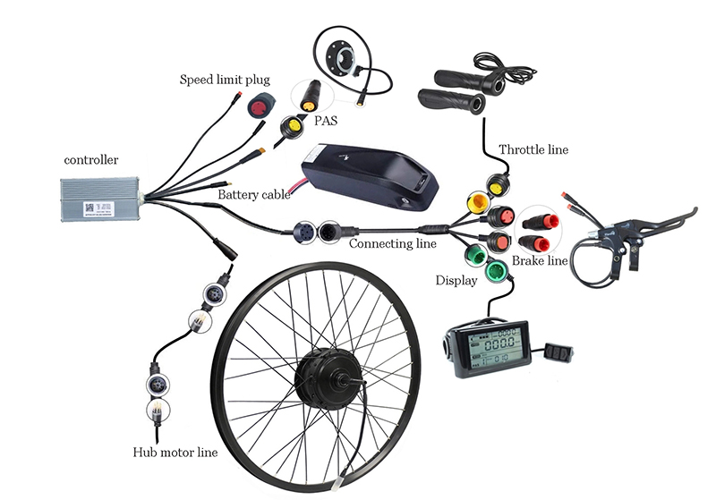

*Figure 5- Modular Electrification System*

### Circuit Development:

Our team aimed to design and develop our own electrical system to connect the given electrification system with the app we design via Bluetooth. The ESC controller is responsible for regulating the motor's power and converting the 48V battery input into the required voltage for the hub motor wheel, optimizing energy consumption and performance. Our addition to this system is an arduino circuit which can connect our electric trike to a mobile platform to enhance the user's experience with our trike. This circuit was developed using arduino components along with a step-down converter to allow connection to the ESC controller such that power can be drawn from the trike battery.

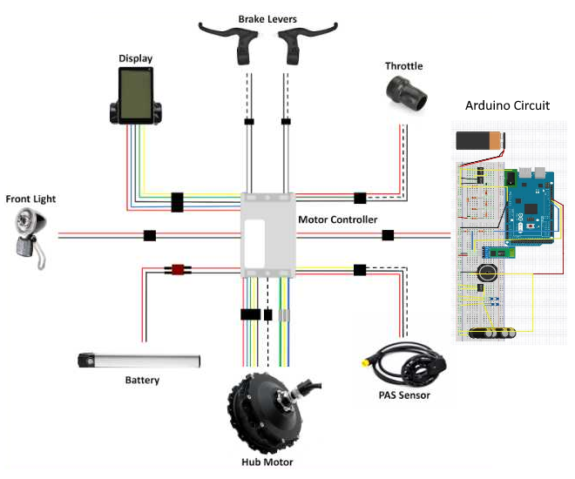

*Figure 6- System wiring diagram including arduino circuit*

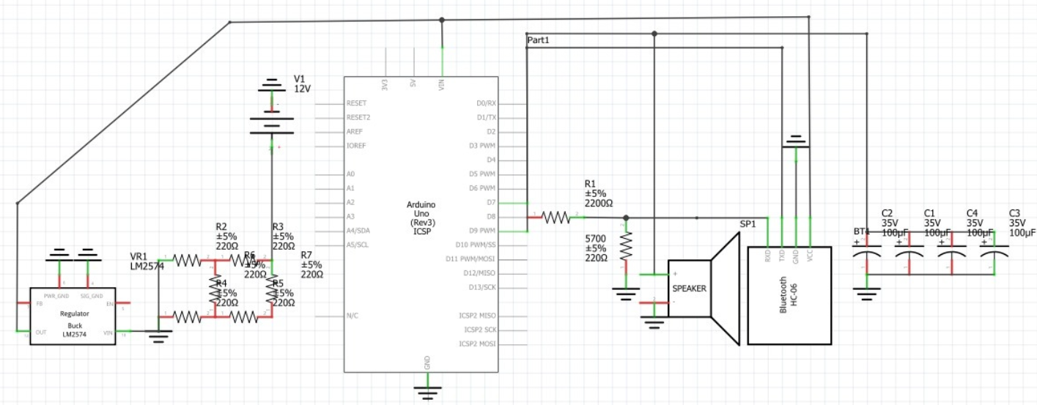

*Figure 7 - Arduino circuit configuration*

### Testing and Evaluation:

Test the electrical system for functionality, safety, and reliability. This includes evaluating the hub motor wheel's performance, the ESC controller's efficiency, and the overall safety of the electrical components when integrated with the trike. Identify areas for improvement or modification based on the test results.

### Design Refinement:

Modify the electrical design based on the testing and evaluation results, addressing any issues or shortcomings identified during the process. This may involve adjusting the ESC controller's settings, optimizing the motor's performance, or making changes to the arduino circuit configuration.

Repeat the steps: Continuously develop, test, and refine the electrical system until the desired level of performance, safety, and reliability is achieved. This iterative approach ensures the trike's electrical components function optimally and provides a safe, efficient, and reliable transportation solution.

By utilizing a hub motor wheel connected to an ESC controller powered by a 48V battery source, the recumbent trike project achieves a balance between performance, efficiency, and safety in its electrical system design. Through continuous development, testing, and refinement, the electrical system will contribute to the overall success of the project and offer a sustainable and accessible transportation option for the residents of Kelowna.

## **Software Integration Phase:**

### *Requirements Gathering*:

Identify the necessary features and functionality for the companion app, considering factors such as user interface, data management, and platform compatibility. For the recumbent trike project, a custom software application called "SKID" will be developed to control the E-Trike's motor and provide additional features to enhance user’s experience with the trike. Requirements for this app include: user account verification, bluetooth security verification, map view implementation, destination selection and navigation, position monitoring and ride tracking, ride data storage to display previous ride data, and database connection and security. This application must also be built on both Android and iOS platforms to allow for a wider range of users. Finally, this application’s development must be fully open sourced to allow for replication in future projects.

### *App Development*:

We developed the SKID companion app using appropriate programming languages and tools, such as Flutter, Firebase, Arduino IDE, and Android Studios. This will ensure compatibility with both Android and iOS platforms while allowing for efficient development and integration of features like Maps Navigation, GPS, and security authentication. This portion of our project is also available on a public GitHub repository to allow for easy access to our source code by future projects. Our team of software developers was tasked with creating this app from scratch and was able to deliver an exceptional beta build of the application, supporting the basic features and requirements laid out.

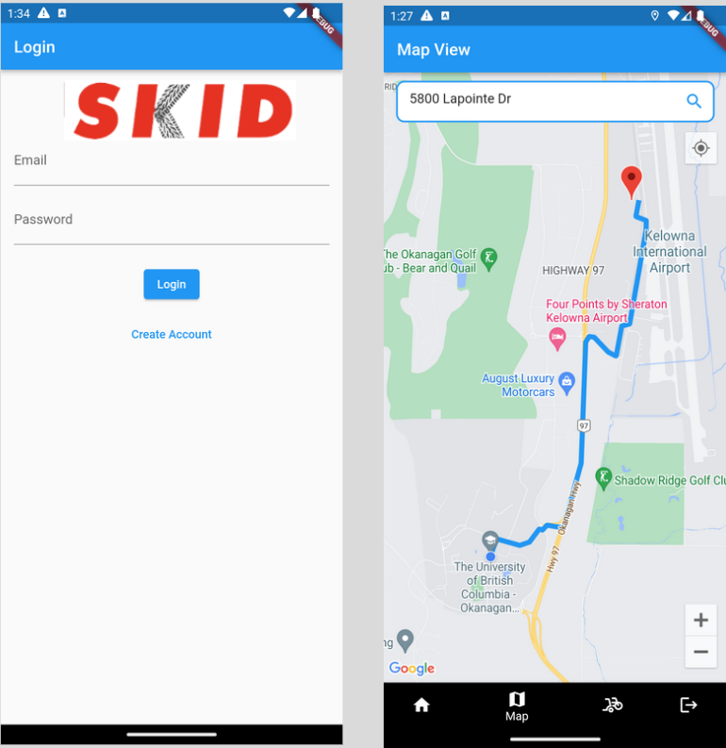

*Figure 8 - SKID App user interface examples*

This software development was completed in many short “sprint” stages in order to execute Agile methodologies with a limited team size. Stages included UI mockups, front end design, Maps API implementation, Navigation implementation, Database setup, backend logic, and security features,.

### Testing and Evaluation:

Test driven development was the strategy implemented in our software design, as the SKID app was constantly being tested for functionality, usability, and compatibility during development. This includes evaluating the effectiveness of the implemented algorithms and methods for ride tracking, database communication and data storage, and user interface design. Identify areas for improvement or modification based on the results.

### Design Refinement:

Modify the SKID app design based on the testing and evaluation results, addressing any issues or shortcomings identified during the process. This may involve fine-tuning the algorithms, enhancing the user interface, or improving the integration of features such as Maps Navigation, GPS, and security authentication.

Repeat Steps: Continuously develop, test, and refine the SKID app until the desired level of functionality, usability, and compatibility is achieved. This iterative approach ensures that the app provides a seamless and user-friendly experience for the trike interface, enhancing the overall utility and appeal of the transportation solution.

### Electrical and software integration:

By developing the SKID app through a structured, iterative process, the recumbent trike project can deliver a comprehensive and intuitive software solution that effectively controls the E-Trike's motor and provides valuable additional features to users.

In addition to the electrical system design, it is essential to highlight the integration of electrical and software components for enhanced functionality and security. An Arduino microcontroller, along with a Bluetooth module HC-06, is used to establish a connection between the recumbent trike and the SKID companion app. This integration allows for secure communication and control of the trike's features through the app. The Arduino microcontroller acts as an intermediary between the electrical components of the trike and the app, processing commands from the app and controlling the trike's motor, ESC, and other components. The Bluetooth module HC-06 enables wireless communication between the trike and the app, providing a seamless and secure connection for users. By integrating the electrical and software aspects of the recumbent trike project, the team can offer a comprehensive transportation solution with advanced security features. This integration not only enhances the overall user experience but also contributes to the safety and reliability of the trike, thus promoting its adoption among the residents of Kelowna as a viable transportation alternative.

This will further support the project's goal of offering a sustainable, accessible, and user-friendly transportation alternative for the residents of Kelowna. By applying the iterative design process to each portion of the recumbent trike project, the team can effectively address complex problems and develop a safe, reliable, and user-friendly transportation solution for the residents of Kelowna.

# IV. Solution Generation and Selection

## Frame and Mechanical Solution:

The initial design for the frame that the rest of the trike was based on was decided using a pros and cons list. This list was constructed taking into consideration our most critical factors. The numerical values of the factors were decided after heavy research done by all team members. These values were then factored in by consensus amongst the team. During discussions more weight was afforded to the opinions of the mechanical team, as they had more experience in this field.

| Factors | Tadpole | Delta |
| --- | --- | --- |
| Weight | 1 | 0 |
| Reliability | 1 | 1 |
| Cost | 1 | 1 |
| Safety | 3 | 2 |
| Ease of use | 3 | 1 |
| Manufacturability | 3 | 2 |

Table 3 Pros and cons of Delta vs Tadpole design

As can be seen from Table 2 the tadpole design had the overall advantage when it came to our factors of interest. This is not to say the delta design has no advantages, for example, delta trikes have tighter turn radii as well as operate better under high speeds, however, we only took into consideration the relevant factors for our purposes.

Steering methods for recumbent bikes also offered a variety of options. Direct and indirect steering methods, as well as underhand and overhand steering alignments. They all offered their own unique sets of pros and cons. Initially, the steering method was decided upon via a similar method, however during the prototyping phase, due to material and equipment restrictions, underhand indirect steering was our only applicable option. This was due to a combination of our adjusted frame design, in addition to requiring minimal adjustments to the frame design.

In the assembly process, we used a combination of threaded fasteners and welding to join our materials. Brazing was ruled out entirely as an option due to the equipment requirements for its use clashing completely with our replicability and low-skill threshold objectives. Welding was our prime method of joining, as it allowed us greater freedom in how we assembled the components. The threaded fasteners also served as a cheap, easy, and fast way to join replicable components to allow for repairability in the future.

Our wheels were restricted to what we were able to find from junkyards and locals giving out free parts on online marketplaces. We used three 26x2.1-inch wheels. As a result, our trike does not operate comfortably in snowy or off-road terrains, heavily limiting its use to when the weather is amicable.

## Brief Review and Description of Previous Solution

This project was previously addressed by a group of Engineering students at the UBCO Capstone competition in 2021 under the supervision of Dr. Ian Foulds. The scope of their project was slightly different as it did not include any electrical components, however, the main focus remained the same - creating an open-sourced Python recumbent trike. This group’s project laid a foundation for our mechanical design and frame, as we were able to take guidance from their successful components and some lessons from the areas of their project requiring improvements. Dr. Foulds provided us with their trike build at the beginning of our project such that we're able to salvage parts from their trike to reduce our own materials costs.

The previous solution had many problems with it, everything from design, and materials choice, to assembly, ease of use, and manufacturing.

The previous solution used aluminum alloys for their materials. Aluminum alloys created many issues with the frame. The softer nature of the metals forced them to implement a much bulkier design. This bulkier design heavily impacted their ease of use, as well as assembly. The increased weight and size not only limit the storage of the trike but also heavily restricted the movement during the assembly phase, proving to be very inefficient. In addition, it greatly reduced the attainable speed of the trike heavily limiting its use. We were able to avoid all of these problems, due to the struggles they faced. As in our design phase, we prioritized the weight of our design to ensure we don't run into the same issue.

Previously brazing was also heavily utilized. In addition, the previous solution was heavily reliant on threaded fasteners for joints. Both of these decisions heavily increased the complexity of the design and greatly increased the weight of the trike. In addition, they also made for a very clunky design. Observing these complications was one of our biggest guiding factors to utilize welding more.

The information provided to us by the previous solution helped greatly in guiding us to avoid similar failures. Between this valuable experience and our own failures, we were able to adjust and optimize our design to its final iteration.

Electrical Solution:

Our interdisciplinary project also includes a much wider scope than the previously recumbent trike, as we decided to electrify our trike and integrate a mobile companion app in order to effectively leverage the skillsets of all of our team members and create a more viable transportation solution to fit the context of modern society.

There were many considerations we took in selecting our final electrical solution, such as selecting a suitable system and components. Given the project constraints, we identified many different options for our motor, battery, and controller systems. For example, we considered adding an induction motor system to our trike originally in order to support regenerative braking with a custom battery/controller configuration. While our original ideas were good in theory, we ultimately found that a hub motor in a comprehensive E-bike conversion kit would be the only viable way for us to complete this electrification. This is mainly due to budget constraints, as we found the individual purchase of separate components to be far more expensive than conversion kits. We compiled a list of potential solutions to order from wholesale sites like Alibaba, weighing each option based on cost, feasibility, and performance. We found that this would be the ideal solution for future groups, as many E-bike conversion kits were readily available within the price range and power specifications required for this project. Our group wanted to begin electrical testing as soon as possible, and most of the solutions we had identified would take months to ship overseas from China due to shipping laws surrounding Lithium-ion batteries. We were luckily able to avoid this wait time as a new solution revealed itself in the late stage of our solution selection process, as a community member posted his refurbished E-bike conversion kit on Facebook marketplace which fit our specifications exactly. We were able to purchase the full conversion kit for $500 CAD, which included a throttle and double hall pedal assist sensor (PAS) to control motor output, an LCD screen to display motor output and assist levels, an electrical brake for the hub motor, and a 500W/48V Lithium Ion battery, all connected through the ESC.

This solution was the best one for our project and was selected for many reasons. Firstly, the hub motor configuration allows for a very simple modular electrical design which was one of the main requirements for this portion of our project. Using a hub motor conversion kit, users can build a manual recumbent trike based on our build guide and simply change the rear tire out with minimal wiring and setup to convert it to an E-trike. This is the maximally modular design solution for this project, which makes the conversion kit the best solution for our purpose. Secondly, this was a much more cost-effective option for us given the performance of the kit we acquired. Since we purchased a second-hand conversion kit, we are able to implement a much better battery and the most powerful motor allowed within our regional constraints possible (500W output) at a considerably discounted price. Finally, this solution was selected to maintain our project’s timeline, as we were able to purchase this kit and begin testing within a two-week period where online purchasing options in our price range would normally take 45-60 days for delivery.

Software Solution:

Our team aimed to strictly adhere to the planned project timeline so that we could complete mechanical construction and electrification primarily and leave time at the end of our project term to develop a paired mobile application. Although this component was not defined as a requirement for our project, we believe that it would greatly improve the viability of our deliverables as it would accentuate the user experience with our trike. We decided to design an Arduino circuit in order to connect our mobile application with the trike, such that a Bluetooth connection with the trike is required in order to start recording ride data within the app.

For our mobile app, we chose to develop using Flutter with a Firebase backend. We selected this solution given the unique modularity of both platforms, as Flutter is able to concurrently design iOS and Android applications while prioritizing ease of use for developers, and Firebase being a backend-as-a-service (BaaS) platform allows for quick and easy application integration. We designed the SKID app as a beta release to showcase the capabilities of our trike and the requirements we set out to achieve with a paired application, but further development could be done in order to integrate more features and release to the general public to encourage people to take this project on themselves.

# V. Final Design Details

The recumbent trike’s final design, features two wheels in the front and a single wheel in the back. This design offers several advantages, including increased stability, improved handling, and a more comfortable riding position. The engineering process involved in the development of the trike focused on sound engineering judgment and methods, utilizing various engineering tools to create diagrams and equations that guided the design process.

Our trike came together with a stunning outcome due to a thorough and detailed design process. Each component of our project was designed to withstand the necessary requirements, down to the materials used on the seat covers which are water resistant and can withstand Kelowna’s harsh weather conditions. Our final product is solid and sturdy due to extensive stress testing at each step along the way through our manufacturing process.

The rear wheel of the trike is equipped with a hub motor, which is connected to an electronic speed controller (ESC) motor controller. This configuration enables the trike to have three distinct modes of operation: pedal-driven acceleration, throttle acceleration, and manual pedaling. These modes offer the rider flexibility in choosing the most appropriate method of propulsion based on their needs and preferences. This design is also modular, as riders can simply switch to a regular wheel should they so choose. The trike meets safety requirements as well, as there are two brakes included for the rider: one electric brake to stop the motor, and one mechanical brake to stop the back wheel entirely. This ensures that the user can feel safe whether the battery is charged or not.

The front wheels are attached to the frame through kingpins and bearings, allowing for smooth steering and maneuverability. This design also reduces the risk of tipping over when cornering, as the center of gravity is lower compared to traditional upright bicycles.

The pedals on the trike are equipped with sensors that enable pedal-driven acceleration. This feature allows the rider to maintain a consistent pedaling cadence, while the hub motor supplements the rider's effort by providing additional power based on the input from the pedal sensors. This mode of operation promotes efficient energy use and ensures a more enjoyable riding experience.

Throughout the development process, the project team employed various engineering tools to create diagrams and equations that informed the design decisions. Computer-Aided Design (CAD) software was used to create detailed 3D models of the trike, allowing the team to visualize and iterate the design in a virtual environment before moving to the manufacturing phase.

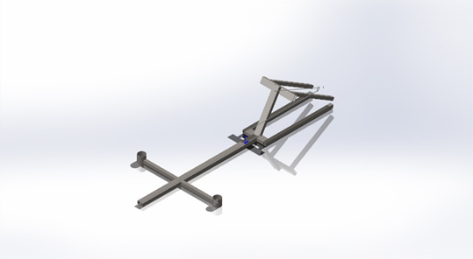

Figure 9: Final CAD of Trike Frame

## Engineering Judgment and Methods

In the development of the recumbent trike, the methods used to create informed engineering decisions were:

Identifying and understanding the problem: We started by recognizing the transportation challenges faced by the residents of Kelowna, including inadequate infrastructure, limited transportation options, and the growing need for sustainable alternatives. This understanding helped shape our goals and requirements.

Research and benchmarking: The team conducted extensive research on existing recumbent trike designs, materials, and technologies. This allowed them to gain a comprehensive understanding of the current state of our potential trike design and areas of improvement.

Prioritizing design objectives: We established priorities for the trike, such as affordability, ease of manufacturing, safety, and sustainability. These priorities guided the design process and helped the team make informed decisions when faced with trade-offs. The requirements and constraints mentioned above were also determined during this stage.

Iterative design process: The project team employed an iterative design process, developing multiple design solutions and evaluating their performance against the project's goals and requirements. This approach allowed the team to learn from each iteration and refine the design until the final, optimized solution was achieved.

Testing and validation: The team conducted rigorous testing and evaluation of the trike's various components and systems, assessing factors such as functionality, reliability, and safety. This data-driven approach ensured that the design decisions were supported by empirical evidence.

The engineering methods employed in the development of the recumbent trike included:

* Computer-Aided Design (CAD): The use of CAD software(Solidworks) enabled the team to create detailed 3D models of the trike and visualize the design in a virtual environment. This allowed for rapid iteration and optimization of the design before moving to the manufacturing phase.

* Prototyping and testing: The project team built and tested physical prototypes of the recumbent trike, validating the design decisions and identifying areas for further refinement. This hands-on approach allowed the team to gain invaluable insights and ensure the trike's performance in real-world conditions.
* By employing sound engineering judgment and methods in the development of the recumbent trike, this systematic and data-driven approach ensured that the final design met the project's goals and requirements, offering an affordable, accessible, and sustainable transportation solution.

## Engineering Tools

#### Manufacturing tools:

* Welding machine: A welding machine is essential for joining metal parts of the trike frame and components. Welding methods such as stick welding, and gas welding were used in the joinery of metal beams, and components to create the chassis of the trike.
* Angle-Grinder: Grinders were used to remove excess material, smooth rough edges, and shape metal components during the manufacturing process.
* Drill: Drills were used for creating holes in various materials, such as metal, plastic, or composite parts of the trike.
* Bending tools: Bending tools, such as tube benders, pipe benders, or sheet metal brakes, were used to shape metal tubing and sheets for the trike's frame and components such as the steering handlebar.
* Measuring and marking tools: Measuring tools, such as measuring tape and calipers, were used to measure and mark components for accurate cutting, drilling, and assembly. Additionally, tools like squares, protractors, and compasses helped with alignment and angles during the fabrication process.
* Vises and clamps: Vises and clamps were used to hold components securely in place during cutting, drilling, or welding operations.
* Hand tools: Various hand tools, such as wrenches, pliers, hammers, and screwdrivers, are used for assembling and disassembling components during the manufacturing process.
* Paint and finishing equipment: Painting equipment, such as spray guns, brushes, and rollers, were used to apply paint or other finishes to the trike's frame and components to protect them from corrosion and improve their appearance

# VI. Final Design Evaluation

## Assessment of Final Design

The recumbent trike successfully addresses the requirements, needs, and constraints set forth at the beginning of the project. The trike is an affordable, accessible, and sustainable transportation solution that caters to the diverse needs of Kelowna's residents. The design is easy to build and customize, allowing individuals to choose between a standard recumbent trike or an electric version with added convenience. The project effectively combines mechanical, electrical, and software components, integrating them seamlessly to create a highly functional and user-friendly product. Please see *Appendix C* for images displaying the outcome of our final design.

## Success or Failure

The Trike is a resounding success. The final design meets the project's goals and requirements, offering a viable transportation alternative to the. The trike is easy to manufacture, affordable, safe, and environmentally friendly. The use of an iterative design process, rigorous testing, and validation, as well as sound engineering judgment and methods, have contributed immensely to the project's success. Furthermore, the collaboration between project partners and stakeholders has facilitated the promotion and adoption of the recumbent trike within the community.

## Recommendations for Further Work

Enhance the SKID app: Additional features and functionality could be added to the app to provide users with a more comprehensive and engaging experience. This may include advanced navigation options and integration with social media platforms for sharing rides and achievements.

Extensive R&D: Research and testing alternative materials for the trike's frame and components could lead to further improvements in weight, strength, and durability. This may include the use of advanced composites, lightweight metals, or recyclable materials.

Implement Modularity: A modular design approach could enable users to easily customize their recumbent trike by adding or removing various components and accessories. This may include cargo attachments, weather protection, or special seating requirements

By pursuing these recommendations for further work, the recumbent trike project can continue to evolve and improve, thus broadening its impact on the transportation landscape in Kelowna and beyond.

# VI. Conclusion

Taking into consideration the lessons learned from a previous project at the UBCO Capstone competition, as well as our own failed prototype attempts, our interdisciplinary team successfully designed and built an electrified tadpole recumbent trike. By utilizing an iterative approach, and consensus-driven decision-making system, we optimized the frame, materials, and assembly processes, resulting in a more efficient, durable, cheap, easily replicated, and functional trike. The integration of an electrical solution through a hub motor conversion kit enhanced the trike's functionality and adaptability while adhering to budget constraints and regional power specifications. Furthermore, we developed a mobile companion app using Flutter and Firebase, which not only improved the user experience but also showcased the potential for future expansion and public engagement. This project demonstrates the successful combination of mechanical, electrical, and software solutions, paving the way for accessible, environmentally friendly transportation options that can be built and maintained by a diverse range of users.

# 

# References:

A. Barnes, G. (2022, November 24). Transit riders in Kelowna community concerned about safety. Revelstoke Review. Retrieved December 1, 2022, from https://www.revelstokereview.com/news/transit-riders-in-kelowna-community-concerned -about-safety/

BC Transit Fares Kelowna. BC Transit - Fares - Kelowna. (n.d.). Retrieved December 2, 2022, from https://www.bctransit.com/kelowna/fares

Explaining your British Columbia Electricity & Natural Gas Rates. EnergyRates.ca. (2018, August 15). Retrieved December 2, 2022, from https://energyrates.ca/british-columbia/explaining-your-british-columbia-electricity-natur al-gas-rates/

Kelowna is now the fastest growing city in Canada. (2022, February 9). West Investor. Retrieved from https://www.westerninvestor.com/british-columbia/kelowna-is-now-the-fastest-growing-c ity-in-canada-5046595#:~:text=Kelowna%2C%20B.C.%20is%20officially%20the,40%2 0CMAs%20in%20the%20country.

Razor® PR200 pocket rocket electric pocket bike parts. Razor PR200 Pocket Rocket Electric Pocket Bike Parts - ElectricScooterParts.com. (n.d.). Retrieved December 2, 2022, from https://electricscooterparts.com/razorpocketbike.html

Sensiba, J. (2019, May 11). A Better Route Planner & Other Open Source Projects Need Our Help. CleanTechnica. Retrieved December 2, 2022, from https://cleantechnica.com/2019/05/11/abrp-other-open-source-projects-need-our-help/ G. Seymour,

(2021, December 16). No one at the wheel; driver Shortage Forces Kelowna Transit Cutback. Daily Courier. Retrieved December 1, 2022, from https://www.kelownadailycourier.ca/news/article_675b0882-5eca-11ec-bf93-1f616b8d3d ed.html

Theelectricbike. (2022, July 9). E-bike laws in your province. Ebike Canada. Retrieved December 1, 2022, from https://ebikecanada.com/e-bike-laws-in-canada/

Vehicle Registration: Electric Bikes. ICBC. (n.d.). Retrieved December 2, 2022, from https://www.icbc.com/vehicle-registration/specialty-vehicles/Low-powered-vehicles/Page s/Electric-bikes.aspx

# 

# APPENDIX A: Motor Wattage and Operation Cost

Motor wattage used: 500 Watts Number of hours bike used for per day (assumption): 5 Hours Charge per kilowatts in British Columbia: $0.1408

𝑂𝑝𝑒𝑟𝑎𝑡𝑖𝑜𝑛 𝐶𝑜𝑠𝑡 = 500𝑊 × 1 𝐾𝑖𝑙𝑜𝑤𝑎𝑡𝑡 × 5 𝐻𝑜𝑢𝑟𝑠 × 30 𝐷𝑎𝑦𝑠 × $0.1408 1 𝐾𝑊𝑎𝑡𝑡 = $10.56 𝑝𝑒𝑟 𝑚𝑜𝑛𝑡ℎ

# 

# APPENDIX B: Stress Testing Report Using SolidWorks

# APPENDIX C: Final Trike Images

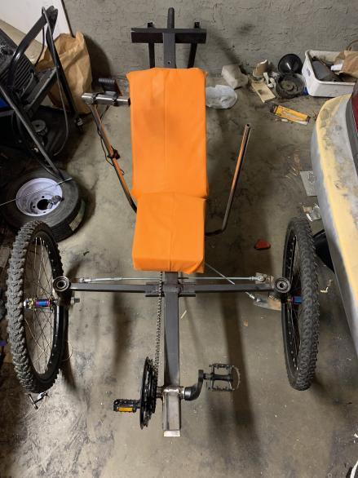

*Final Trike Design*

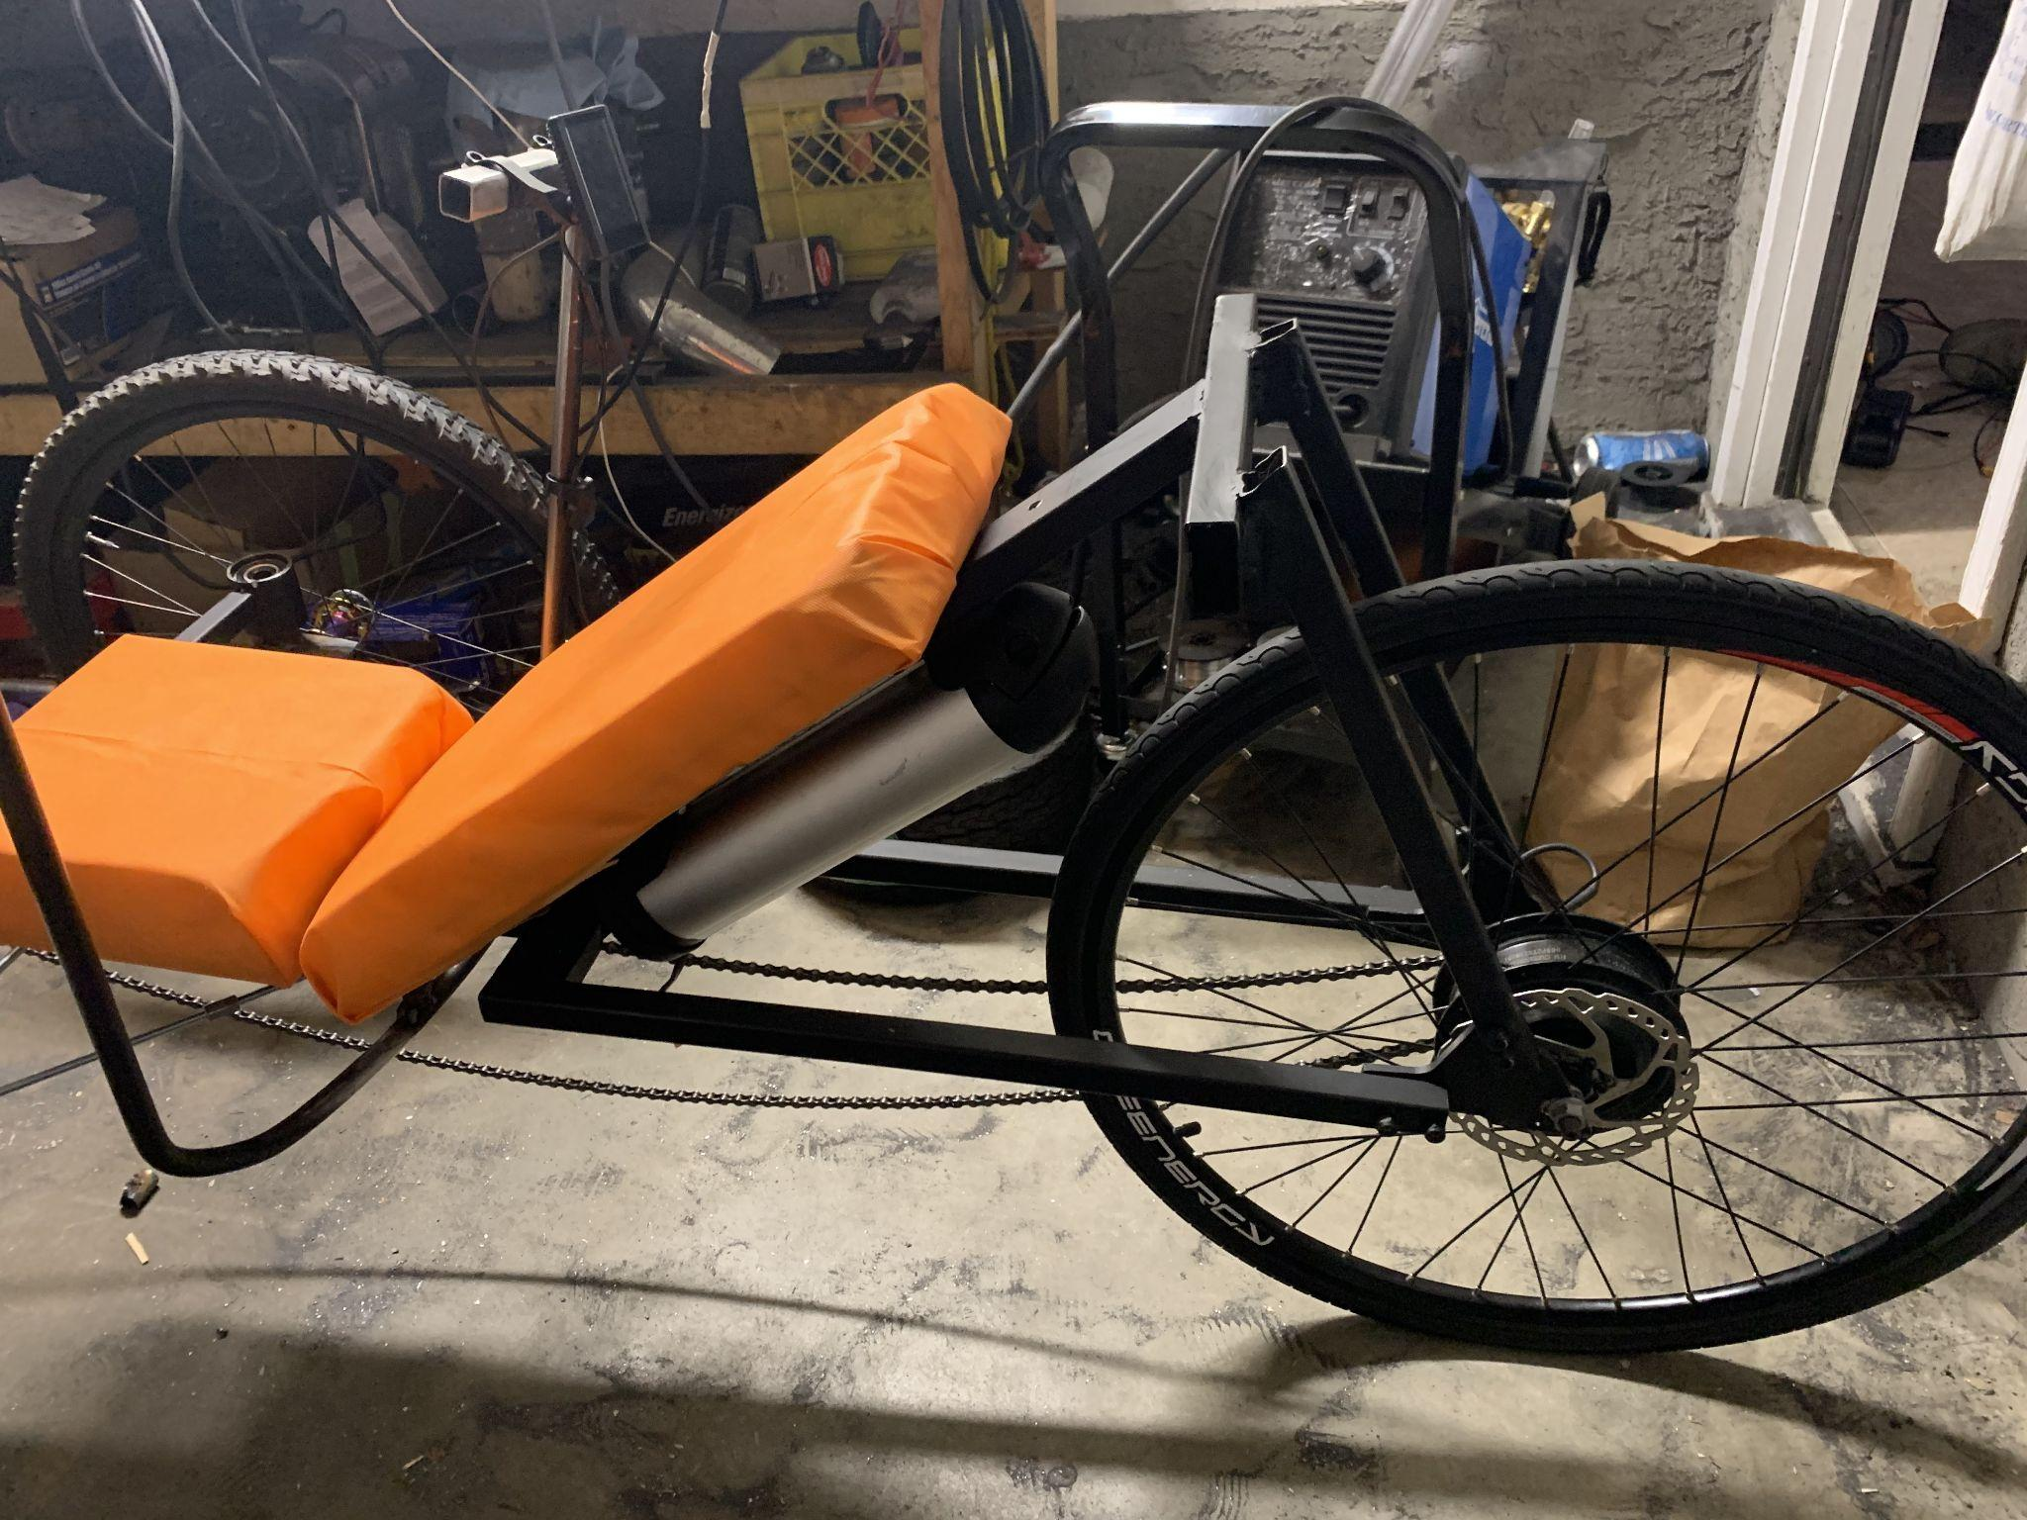

*Final Design displaying battery mount, with wiring through the frame*